Enunciado:
Resuelva la traza de un camino a construir a través de un polinomio del menor grado posible. El camino debe pasar por los tres puntos indicados, coincidentes con puentes existentes como se indica en el croquis siguiente.

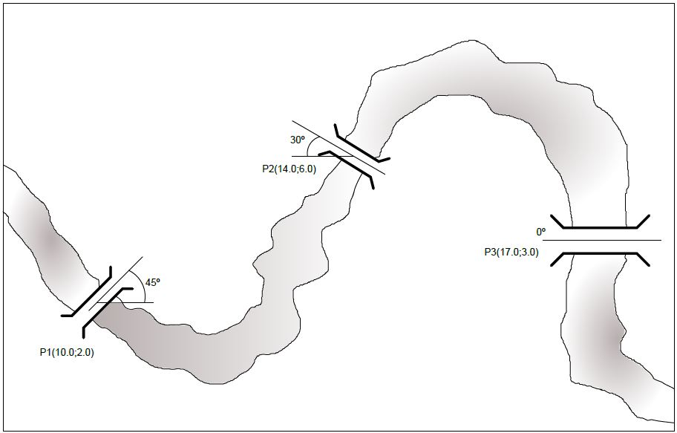

 | x_{k} | f(x_{k}) = y_{k}
X₀, f_{(x0)} | 10 | 2
X₁, f_{(x1)} | 14 | 6
X₂, f_{(x2)} | 17 | 3

Polinomio de Lagrange. Expresiones:

$$P_{n}\left(x\right)=\sum_{k=0}^{n}{y_{k}}⋅L_{k}\left(x\right) L_{k}\left(x\right) = \prod_{i=0, i ≠ k}^{n}{\frac{x - x_{i}}{x_{k} - x_{i}}}$$

$$L_{k}\left(x\right) = \left( \frac{x - x_{0}}{x_{k} - x_{0}} \right) ⋅ \left( \frac{x - x_{1}}{x_{k} - x_{1}} \right) ⋅ ⋯ ⋅ \left( \frac{x - x_{k-1}}{x_{k} - x_{k-1}} \right) ⋅ \left( \frac{x - x_{k+1}}{x_{k} - x_{k+1}} \right) ⋅ ⋯ ⋅ \left( \frac{x - x_{n}}{x_{k} - x_{n}} \right)$$

Obtención de los Lagrangianos

$$L_{0}\left(x\right) = \left( \frac{x - 14}{10 - 14} \right) ⋅ \left( \frac{x - 17}{10 - 17} \right)=\frac{(x-14)}{-4}⋅\frac{(x-17)}{-7}=\frac{\left(x-14\right)\left(x-17\right)}{28}$$

$$L_{0}\left(x\right)=\frac{1}{28}x^{2}-\frac{31}{28}x+\frac{119}{14}$$

$$L_{1}\left(x\right) = \left( \frac{x - 10}{14 - 10} \right) ⋅ \left( \frac{x - 17}{14 - 17} \right)=\left(\frac{x-10}{4}\right)⋅\left(\frac{x-17}{-3}\right)=\frac{\left(x-10\right)\left(x-17\right)}{-12}$$

$$L_{1}\left(x\right)=-\frac{x^{2}-27x+170}{12}=-\frac{1}{12}x^{2}+\frac{9}{4}x-\frac{85}{6}$$
$$L_{1}\left(x\right)=-\frac{1}{12}x^{2}+\frac{9}{4}x-\frac{85}{6}$$

$$L_{2}\left(x\right) = \left( \frac{x - 10}{17 - 10} \right) ⋅ \left( \frac{x - 14}{17 - 14} \right)=\left(\frac{x-10}{7}\right)⋅\left(\frac{x-14}{3}\right)=\frac{\left(x-10\right)\left(x-14\right)}{21}$$

$$L_{2}\left(x\right) =\frac{x^{2}-24x+140}{21}=\frac{1}{21}x^{2}-\frac{8}{7}x+\frac{20}{3}$$
$$L_{2}\left(x\right)=\frac{1}{21}x^{2}-\frac{8}{7}x+\frac{20}{3}$$

Obtención del Polinomio de Lagrange:
 | X_{k} | F(x_{k})= y_{k}
X₀, f_{(x0)} | 10 | 2
X₁, f_{(x1)} | 14 | 6
X₂, f_{(x2)} | 17 | 3

$$P_{n}\left(x\right)=\sum_{k=0}^{n}{y_{k}}⋅L_{k}\left(x\right)$$
$$P_{2}\left(x\right)=2⋅\left(\frac{1}{28}x^{2}-\frac{31}{28}x+\frac{119}{14}\right)+6⋅\left(-\frac{1}{12}x^{2}+\frac{9}{4}x-\frac{85}{6}\right)+3⋅\left(\frac{1}{21}x^{2}-\frac{8}{7}x+\frac{20}{3}\right)$$
$$P\left(x\right)=\left(\frac{2}{28}x^{2}-\frac{62}{28}x+\frac{238}{14}\right)+\left(-\frac{6}{12}x^{2}+\frac{54}{4}x-\frac{510}{6}\right)+\left(\frac{3}{21}x^{2}-\frac{24}{7}x+\frac{60}{3}\right)$$
$$P\left(x\right)=\left(\frac{1}{14}x^{2}-\frac{31}{14}x+17\right)+\left(-\frac{1}{2}x^{2}+\frac{27}{2}x-85\right)+\left(\frac{1}{7}x^{2}-\frac{24}{7}x+20\right)$$
$$P\left(x\right)=\left(\frac{1}{14}x^{2}-\frac{1}{2}x^{2}+\frac{1}{7}x^{2}\right)+\left(-\frac{31}{14}x+\frac{27}{2}x-\frac{24}{7}x\right)+\left(17-85+20\right)$$

$$\boxed{P\left(x\right)=-\frac{2}{7}x^{2}+\frac{55}{7}x-48}$$

